|  |  |  |
| --- | --- | --- |
|  | Standard | Technology |

|  |  |  |  |
| --- | --- | --- | --- |
| Title: | User requirement specification for an interlocking rule generator tool | Unique Identifier: | 240-170000295 |
|  | Alternative Reference Number: | n/a |
|  | Area of Applicability: | Engineering |
|  | Documentation Type: | Standard |
|  | Revision: | 0.1 |
|  | Total Pages: | 8 |
|  | Next Review Date: | As required |
|  | Disclosure Classification: | Controlled Disclosure |

|  |  |  |  |  |  |
| --- | --- | --- | --- | --- | --- |
| Compiled by |  | Approved by |  | Authorized by |  |
|  |  |  |  |  |  |
| Tjaart Visser  Engineer - Control and Automation |  | Rishi Hariram  Acting Manager - Control and Automation |  | Richard McCurrach  Senior Manager - PTMC |  |
| Date: |  | Date: |  | Date: |  |
|  |  |  |  | Supported by SCOT/SC |  |
|  |  |  |  |  |  |
|  |  |  |  | Marlini Sukhnandan  Telecontrol & SCADA SC Chairperson |  |
|  |  |  |  | Date: |  |

Content

Page

1. Introduction 3

2. Supporting clauses 3

2.1 Scope 3

2.1.1 Purpose 3

2.1.2 Applicability 3

2.2 Normative/informative references 3

2.2.1 Normative 3

2.2.2 Informative 3

2.3 Definitions 3

2.3.1 General 3

2.3.2 Disclosure classification 4

2.4 Abbreviations 4

2.5 Roles and responsibilities 4

2.6 Process for monitoring 5

2.7 Related/supporting documents 5

3. Interlocking Rules Requirements 5

3.1 Fundamental Interlocking Requirements 5

3.2 General Interlocking Rules Philosophy 5

3.3 Transfer Bar Interlocking Rules Philosophy 5

3.4 Earthing Interlocking Rule Philosophy 5

4. Interlocking Rule Generator Tool Requirements 6

4.1 Scalability and future goals 6

4.2 Product Development Scope Methodology 6

4.2.1 First Interlocking Rule Generator Tool Implementation 6

4.2.2 Future Functionality Recommendations 6

4.3 Interlocking Rule Set output format 7

5. Interlocking Rule implementation 7

6. Authorization 7

7. Revisions 7

8. Development team 8

9. Acknowledgements 8

Figures

Figure 1: Single Line Interlocking Diagram of Dinaledi Substation 7

# Introduction

Eskom requires interlocking as the strategy to reduce equipment damages, human injuries/fatalities and hence the operational cost. The interlocking is a concept of applying Boolean equations to establish the HV plant interlock conditions that must be satisfied in order to operate a particular plant device/equipment. Eskom has made huge investments to develop substation infrastructure capable of providing interlocking.

With the technology vision to implement interlocking at all Transmission substations (as per technology migration strategies), there is an increasingly demand to generate interlocking rules. Transmission substations differ in topology, phases of technology implemented and in some cases, station specific operating transfer procedures. This necessitates a User Requirement Specification to standardise interlocking rule creation to ensure consistency, completeness and to reduce the expenditure of outsourcing for external expertise on a per substation basis.

It should be noted that the interlocking system would not prevent erroneous operations, but prohibit any attempt to operate a particular plant device if the interlocking conditions have been violated.

# Supporting clauses

## Scope

This document describes the requirements for an interlocking rule generator tool, as well as the interlocking rule philosophies that will standardise the creation of substation specific interlocking rules. Substation transfer bar operating procedures are sometimes unique and will require additional interlocking rules that are not governed by the interlocking rule philosophies in this document.

### Purpose

The purpose of this document is to capture and describe the user requirements for the development and implementation of an interlocking rule generator tool that applies Eskom interlocking rule philosophies.

### Applicability

This document shall apply to the Transmission Division.

## Normative/informative references

Parties using this document shall apply the most recent edition of the documents listed in the following paragraphs.

### Normative

1. ISO 9001, Quality Management Systems.
2. 240-170000295, Interlocking guideline for ESKOM HV yard SCADA HMI equipment, Rev 2.
3. 240-75909223, Standard terminology procedure for the issuing of operation instructions, Rev 2.

### Informative

None.

## Definitions

### General

| Definition | Description |
| --- | --- |
| Bay Processor | An RTU dedicated to the supervisory needs of a single Protection Scheme |
| DCS | Distributed Control System (DCS) is a control system method that is spread, or distributed, among several different unit processes in a plant. |
| HMI Bay Control Enabled | HMI is enabled for the EA to control plant on a per bay basis at the substation. |
| Master Station | Remote control centres including National Control Centre, Standby National Control, Regional Control Centres, Power Station Electrical Operating Desk and the Substation HMIs. |
| Operating Diagram | Operating Diagram (displayed on an Operating Device) means the diagram in a control centre, or in a power station control room indicating the operating position and state of all apparatus. |
| Operating Device | Mimic Panel or SCADA Human Machine Interface (HMI) at a Power Station or Substation Control Room |
| SCADA HMI | The human interface used for the operation and monitoring of the Substation. |
| SCS | Substation Control System. An integrated and co-ordinated system that performs the tasks of SCADA, substation automation and offers a single point of control, monitoring and alarm annunciation (HMI) to the substation operator. |
| Shall | Means that these requirements are non-negotiable and are to be provided. |
| Stray voltage | The presence of electrical potential on a line or an apparatus relative to a grounded object that ideally should not have a voltage difference between the two objects. |

### Disclosure classification

Controlled disclosure: controlled disclosure to external parties (either enforced by law, or discretionary).

## Abbreviations

|  |  |
| --- | --- |
| Abbreviation | Description |
| DCS | Distributed Control System |
| EOD | Electrical Operating Desk |
| GIS | Gas Insulated Switchgear |
| HMI | Human Machine Interface |
| HV | High Voltage |
| RTU | Remote Terminal Unit |
| SCADA | Supervisory Control and Data Accusation |
| SCS | Substation Control System |
| TOC | Transmission Operating Centre |

## Roles and responsibilities

Even though the intent is for the interlocking rule generator tool to be 100% correct and complete, the Centre of Excellence must implement a process for the verification and correction of the generator tool’s output before the rules are implemented in a substation.

## Process for monitoring

Changes in interlocking requirements between Control Automation equipment and HV Yards, as well as change in technology shall be monitored and if necessary, this document shall be revised.

## Related/supporting documents

Not applicable.

# Interlocking Rules Requirements

The requirements and philosophies that will govern the creation of interlocking rules are outlined in this section.

## Fundamental Interlocking Requirements

Interlocking systems in all applications described within the scope of this document is required to satisfy three basic requirements:

1. To protect humans and plant against erroneous operational switching.
2. To protect humans and plant when switching conditions are unsafe.
3. To help ensure National Grid stability.

## General Interlocking Rules Philosophy

The interlocking rule generator shall produce a rule set that prevents erroneous operational switching conditions and are described as follows:

* Opening/closing of an isolator on load.
* Closing a breaker or isolator and energising an earthed circuit.
* Energising or de-energising of an unearthed line via an isolator. E.g. energising line capacitance (charging current) or de-energising stray voltage present on a line.
* Operations related to Transfer functionality.

**It must be noted that the diversion of current, as would occur when selecting a circuit from one busbar to another, is not considered as opening an isolator on load.**

A pseudo parameter, No Line Voltage (NLV), shall be defined for every feeder to indicate if the feeder has a voltage exceeding 30 kV.

## Transfer Bar Interlocking Rules Philosophy

The interlocking rule generator shall produce a rule set that complies with the following conditions:

* Operations related to Transfer functionality.
* Suspensive to a Transfer Permission Key (TPK) from the designated transfer bar protection scheme for any feeder capable of going on transfer.

## Earthing Interlocking Rule Philosophy

Interlocking must prevent an operator from energising an earthed circuit. This can be achieved in an infinite different ways. It is therefore important to standardise how this is accomplished to ensure consistency throughout Transmission. The interlocking rule generator tool shall apply the following earthing requirements:

* Every earthing capable HV plant apparatus shall be accounted for by the interlocking logic during the operation of any of the controllable HV plant devices.
* The interlocking rules shall ignore the status of earthing capable HV plant devices that are electrically disconnected from the HV plant devices that are being operated.
* A pseudo parameter hierarchy for earthing shall be defined to group earthing capable HV plant devices at the following substation levels:
  + No Earth on the Line (NEL): to indicate that no controllable earth apparatus has been applied to the feeder. This shall be done for all the feeders at the substation.
  + No Earth on the Busbar (NEB): to indicate that no controllable earth apparatus has been applied indirectly via a NEL or directly to the busbar or busbar section.

# Interlocking Rule Generator Tool Requirements

## Scalability and future goals

The solution shall have the ability to expand seamlessly in order to meet current and future needs. Future improvements should be stated, but should rather be postponed if they will otherwise materially increase the project cost or time.

## Product Development Scope Methodology

### First Interlocking Rule Generator Tool Implementation

With an immediate need for an interlocking rule generator tool, it is strongly recommended that the scope of the said tool be limited to the following minimum requirements for the first iteration of the tool:

* Full compliance to section 3, interlocking rules requirements.
* Manual configuration of substation topology, High-Voltage (HV) plant apparatus suspensive to interlocking rules and earthing pseudo parameter definitions.
* The tool output shall be limited to a logic table listing all the interlocking logic rules for all the states of controllable HV plant apparatus.

### Future Functionality Recommendations

The following optional functionality functions are envisioned to be incorporated (directly or indirectly) in the interlocking rule generator tool in future: (not limited to)

* The substation topology and HV plant shall be visualised in the form of a single line diagram. The diagram shall label the HV plant apparatus according to the naming convention used for the interlocking rules and show the pseudo parameters (i.e. No Earth Busbar). An example of such a diagram is showed in Figure 1 below.
* Logic rule simulation, ideally together with the live view of the single line diagram described above.
* Device specific interlocking configuration files that will automate and streamline the configuration of the generated interlocking rules in the control automation equipment such as the Gateway.

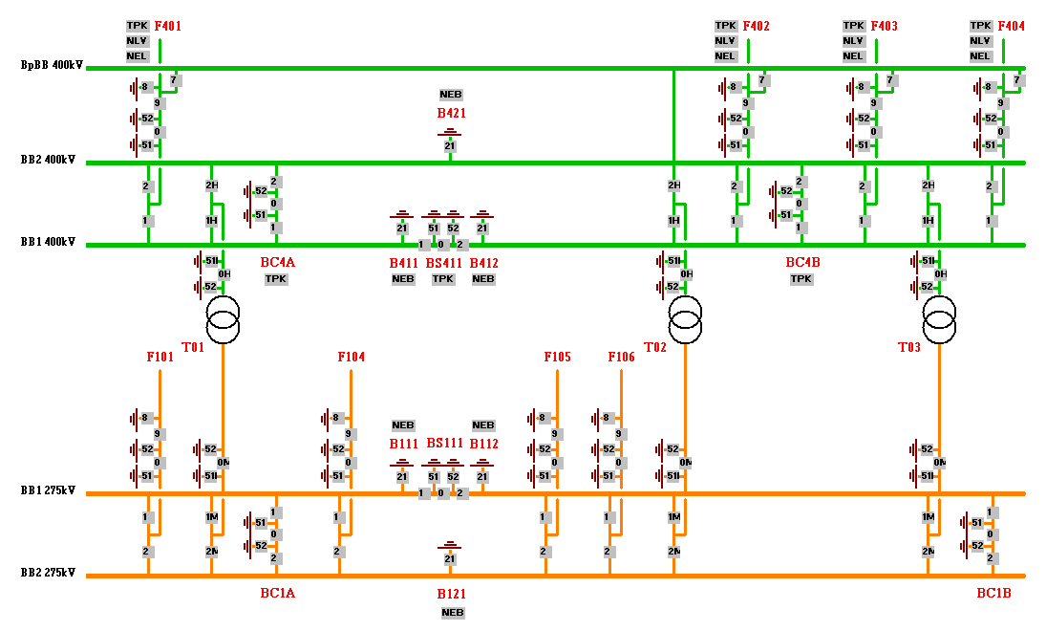

Figure 1: Single Line Interlocking Diagram of Dinaledi Substation

## Interlocking Rule Set output format

The output of the interlocking rule generator tool shall:

* Standardise the naming convention used for:
  + Bay names
  + Q-number naming
  + Controllable HV plant apparatus description naming
  + Logic symbols to present interlocking equations
* Present the interlocking rules in a table guise, providing the internal (to the bay) logic and external (to the bay) logic for every end state of every controllable HV plant apparatus in the substation.

# Interlocking Rule implementation

Not applicable.

# Authorization

This document has been seen and accepted by:

| Name and surname | Designation |
| --- | --- |
| Ian Naicker | Chief Engineer – Control Automation |
| Quinton Labuschagne | Senior Consultant –  Applications |

# Revisions

| Date | Rev. | Compiler | Remarks |
| --- | --- | --- | --- |
| Oct 2020 | 0 | TC Visser | First draft. |

# Development team

The following people were involved in the development of this document:

* Tjaart Visser

# Acknowledgements

* Quinton Labuschagne
* Teboho Lekeno